FULL SUBTRACTOR

AIM: TO PERFORM AN FULL SUBTRACTOR USIMG LOGIC SIM.

INPUT:

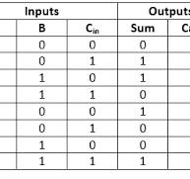

OUTPUT: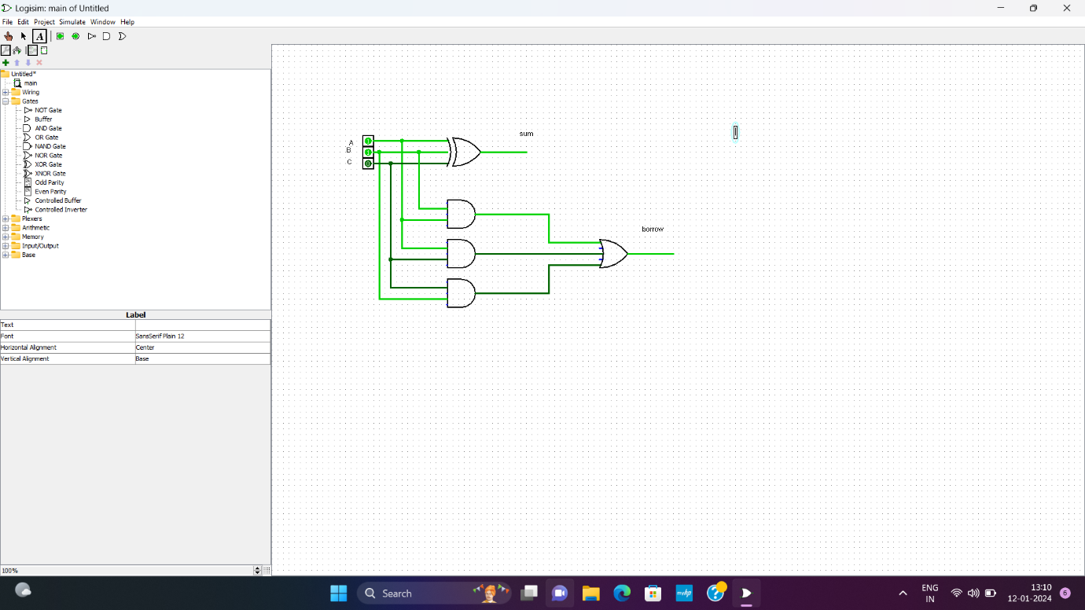

RESULT: THIUS THE PROGRAM WAS EXECUED SUCCESFULLY USING LOGIC SIM.